Optimizing User, Group, and Role Management with Access Control and Workflows

Step 1: Setting Up ServiceNow Instance
- Go to the ServiceNow Developer Site. (https://developer.servicenow.com/)
- Sign In to the Developer Account.
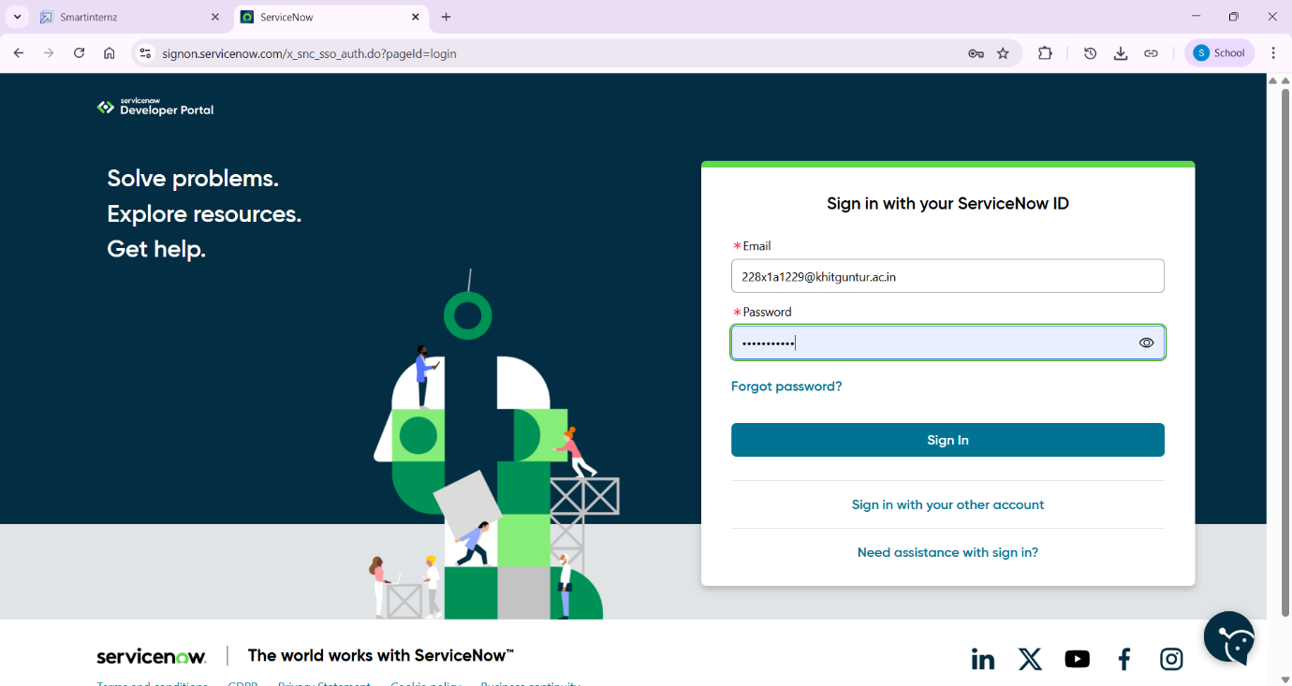
- Request a Personal Developer Instance (PDI)
- Click on the profile icon at the top-right corner.
- Select “Manage Instance” or go directly to the link.
- Click “Request Instance”.
- Choose the latest version (default selection is recommended).
- Access your Instance
- You’ll get an instance URL (https://dev225052.service-now.com)
- Click “Open Instance” to launch it.
- Your admin credentials (username & password) will be shown-copy and save
them securely.
- Log in to Your Instance.
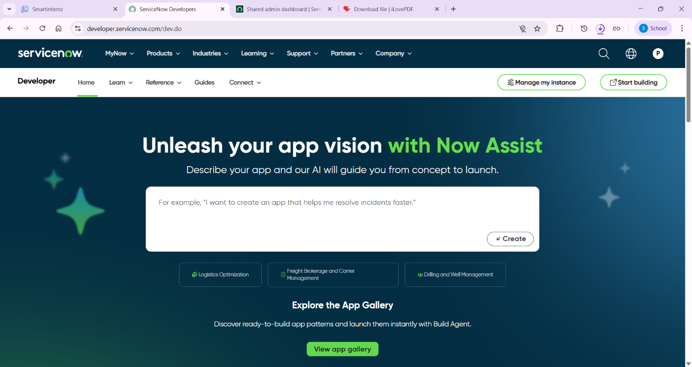
Usage:
- Use the Application Navigator (left sidebar) to explore modules like:
- Incident, Problem, Change Management.
- Service CatLog.
- Configuration Management (CMDB).
- Workflow Editor / Flow Designer.
- Use App Engine Studio or ServiceNow Studio to build or customize apps.

Step 2: Create Users
A user in ServiceNow is an individual record (stored in the sys_user table) representing a person who can log in to the instance to access data, submit requests, or manage tasks. These accounts define identity, roles, and preferences, allowing personalized access to the platform.
- Open service now.
- Click on All >> search for users.
- Select Users under system security.
- Click on new and enter the following details of User1 of User2:
User1:
- User ID: alice
- First Name: alice
- Last Name: P
- Email: alice@gmail.com
User2:
- User ID: bob
- First Name: Bob
- Last Name: P
- Email: bob@gmail.com
- After entering all details click Submit.
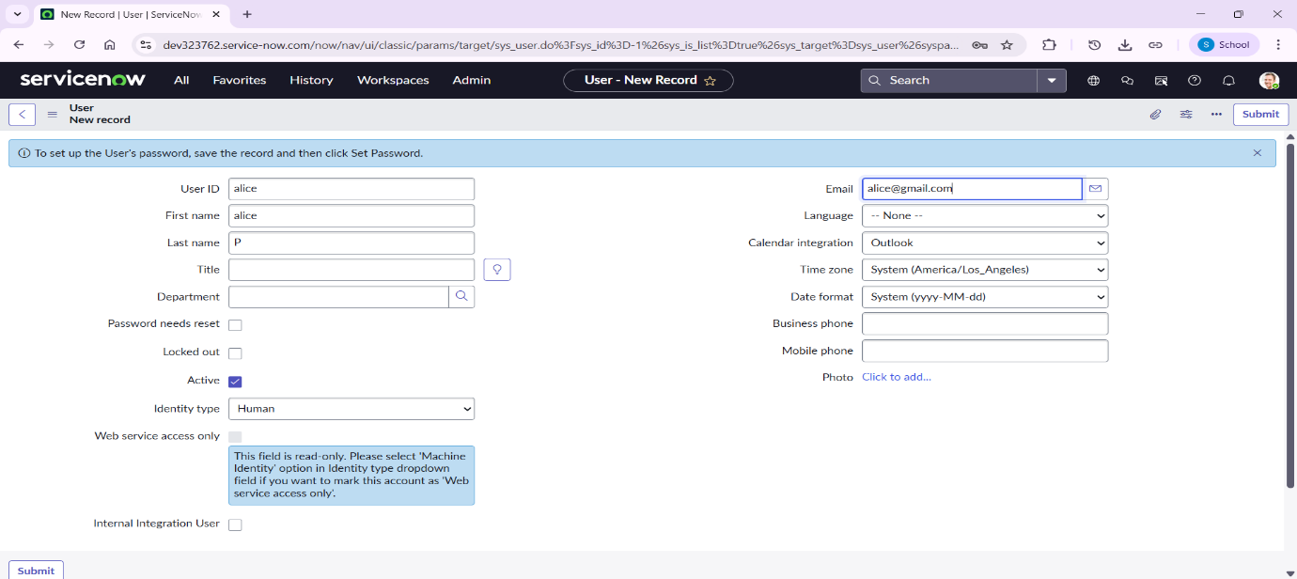
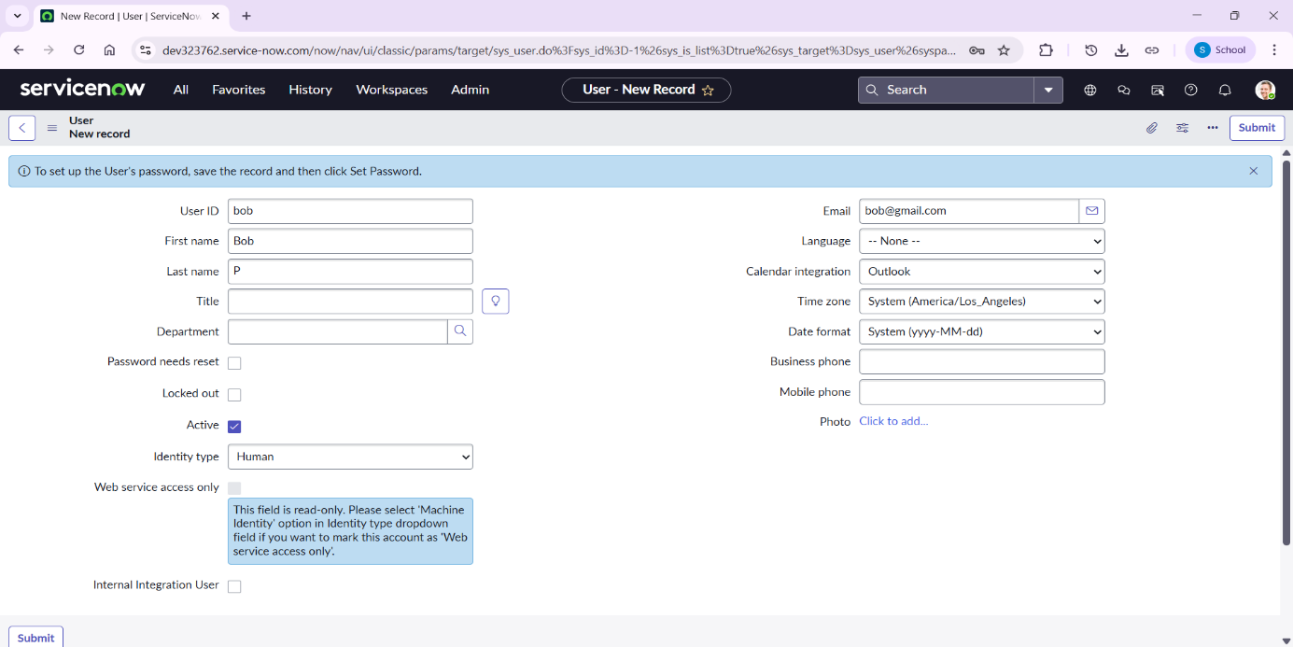
Step 3: Create Groups
A group in ServiceNow is a foundational, (defined in the sys_user_group table) used to organize users with shared purposes, such as team members, for assigning tasks, roles, and permissions. Groups streamline administration by allowing roles (like ITIL) and permissions to be assigned to the group, which are inherited by all members. They are critical for workflow, including incident assignment, approval processes, and email notifications.
- Open service now.
- Click on All >> search for groups.
- Select Users under system security.
- Click on new and enter the following details.
- Name: Project Team.
- After entering all details click Submit.
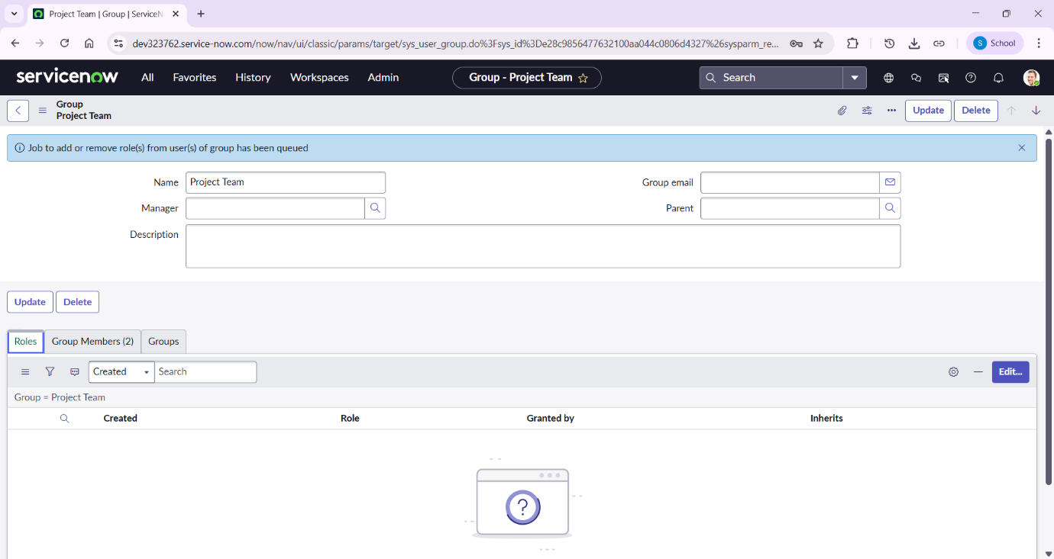

Step 4: Create Roles
In ServiceNow, a role is a collection of permissions stored in the sys_user_role table that determines what a user can access, view, or modify within the platform. Roles act as a security mechanism (RBAC) to ensure users have the necessary permissions for their job functions.
- Open service now.
- Click on All >> search for roles.
- Select Users under system security.
- Click on new and enter the following details of Role1 of Role2:
Role1:
- Name: Project Member.
- After entering all details click Submit.
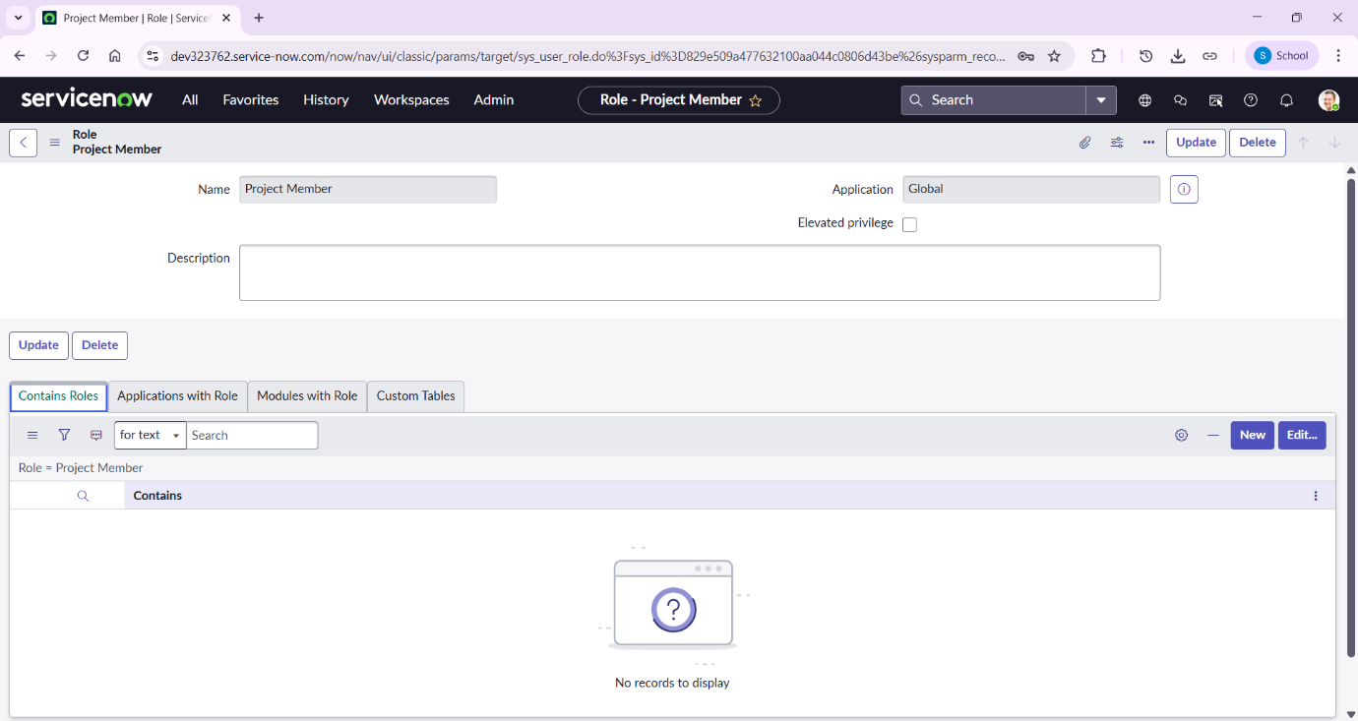
Role2:
- Name: Team Member.
- After entering all details click Submit.
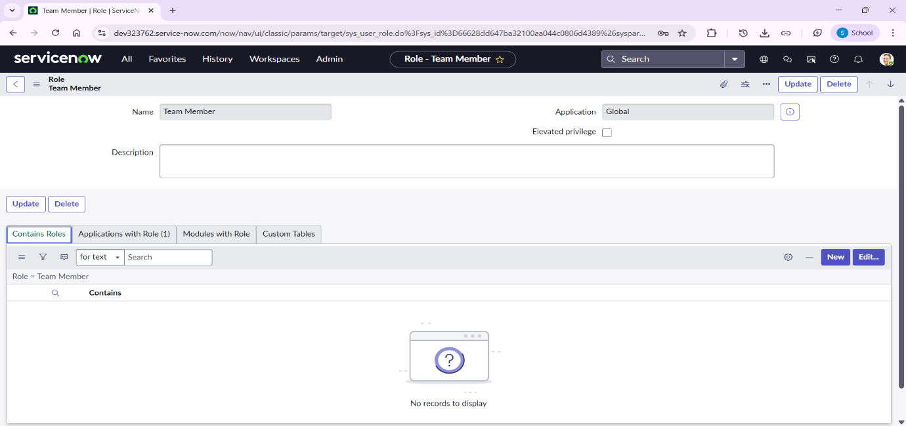

Step 4: Create Table
In ServiceNow, a table is the fundamental database structure for storing data, similar to a spreadsheet or database table, composed of fields (columns) that hold specific data types and records (rows) that represent individual entries, like a user or an incident. Every action in ServiceNow, from creating an incident to managing users, involves interacting with data stored in these tables, which form the backbone of applications and configurations.
- Open service now.
- Click on All >> search for tables.
- Select tables under system definition.
- Click on new.
- Enter the following details to create a new table:
Table1:
- Label: project table.
- Check the boxes: Create module & Create mobile module.
- Under new menu name: project table.
- Under table columns give the columns:
Column Label | Type
Project ID | Integer
Project Name | String
Project Manager | String
Start Date | Date
End Date | Date
Status | Choice
Description | String
- After entering all details click Submit.
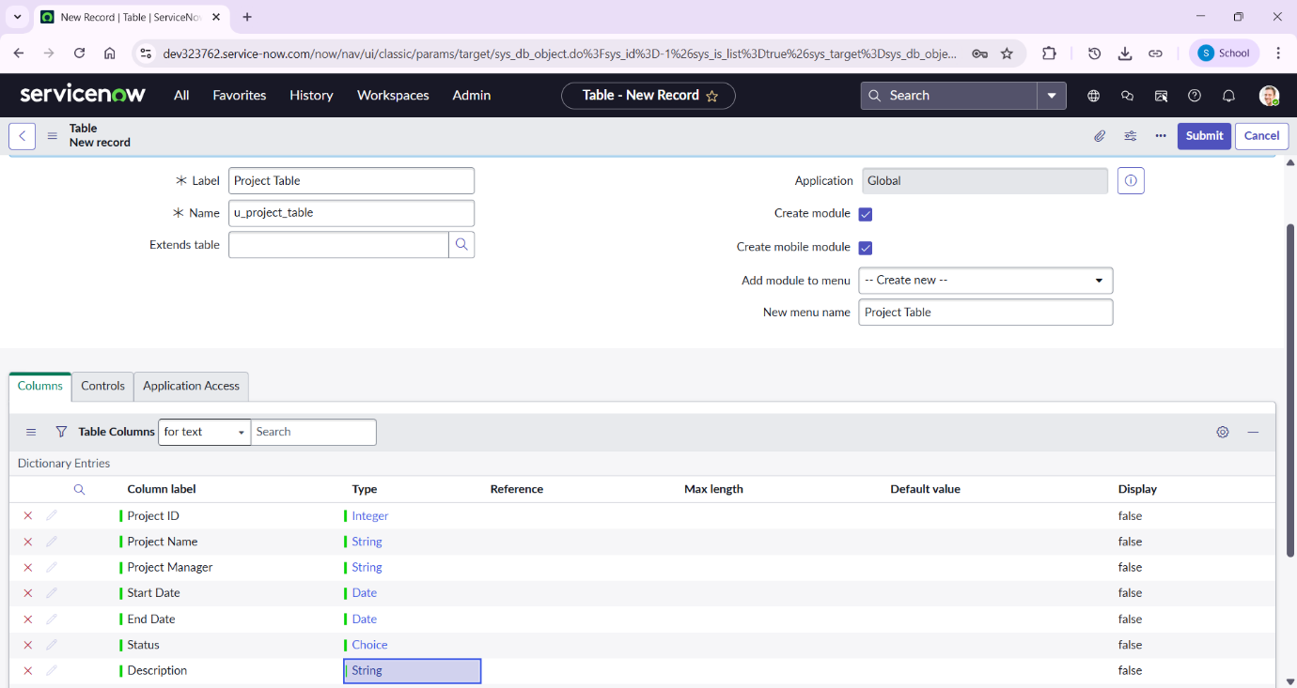
Table2:
- Label: task table 2.
- Check the boxes: Create module & Create mobile module.
- Under table columns give the columns:
Column Label | Type
Task ID | Integer
Task Name | String
Assigned To | String
Due Date | Date
Status | Choice
Comments | String
- After entering all details click Submit.
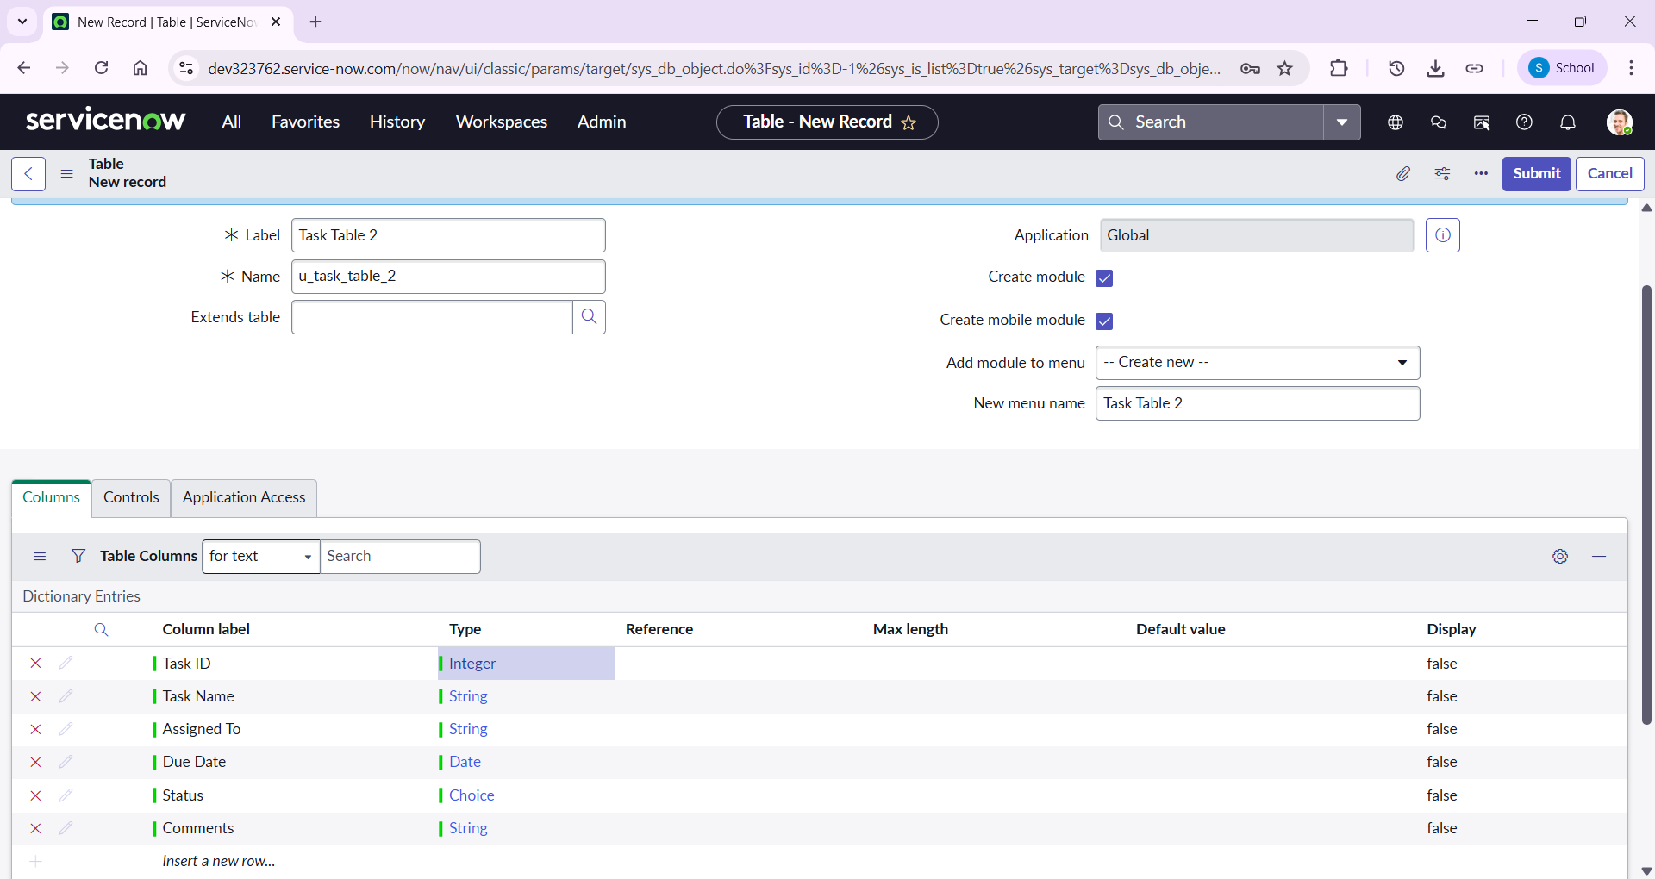

Step 5: Assign users to groups
Assigning users to groups in ServiceNow is a, fundamental administrative action used to organize users for task routing, role-based access control, and approvals. Users are assigned via the sys_user_grmember table (Group Members) by navigating to User Administration > Groups, selecting a group, and adding users in the Members related list.
- Open servicenow.
- Click on All >> search for groups.
- Select tables under system definition.
- Select the project team group.
- Under group members.
- Click on edit and Select alice p and bob p and save.
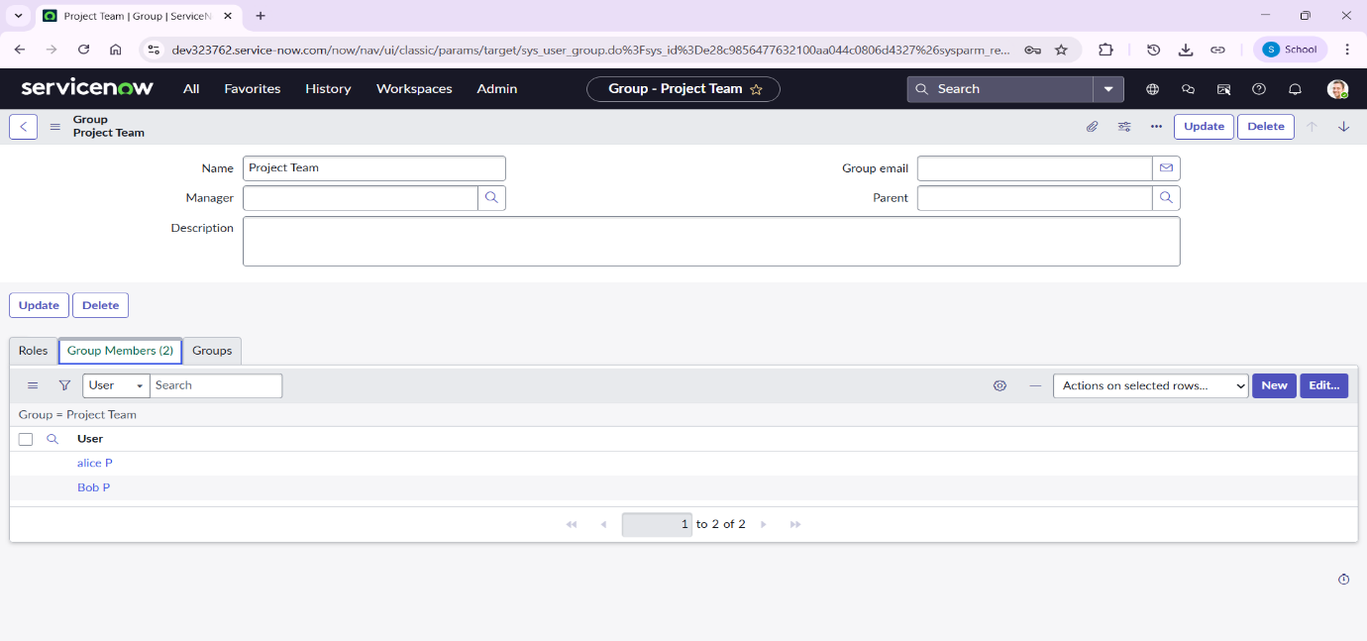

Step 6: Assign roles to users
Assigning roles to users in ServiceNow is the process of granting specific permissions or access rights to a user profile, directly or via groups, controlling their ability to view or modify data. This is managed by administrators in the sys_user table, enabling access to applications and modules.
- Assign roles to alice user:
- Open servicenow.
- Click on All >> search for user
- Select tables under system definition
- Select the project manager user
- Under project manager
- Click on edit and Select project member and save
- click on edit add u_project_table role and u_task_table role
- click on save and update the form.
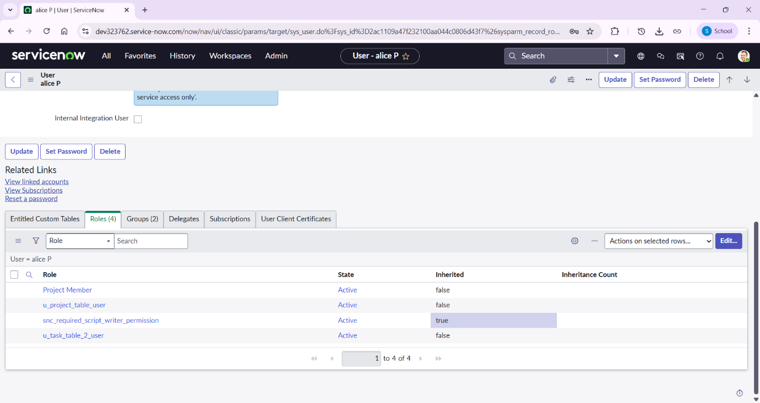
- Assign roles to bob user
  - Open servicenow.
  - Click on All >> search for user.
  - Select tables under system definition.
  - Select the bob p user.
  - Under team member.
  - Click on edit.
  - Select team member and give table role and save.
  - Click on profile icon Impersonate user to bob.
  - We can see the task table2.
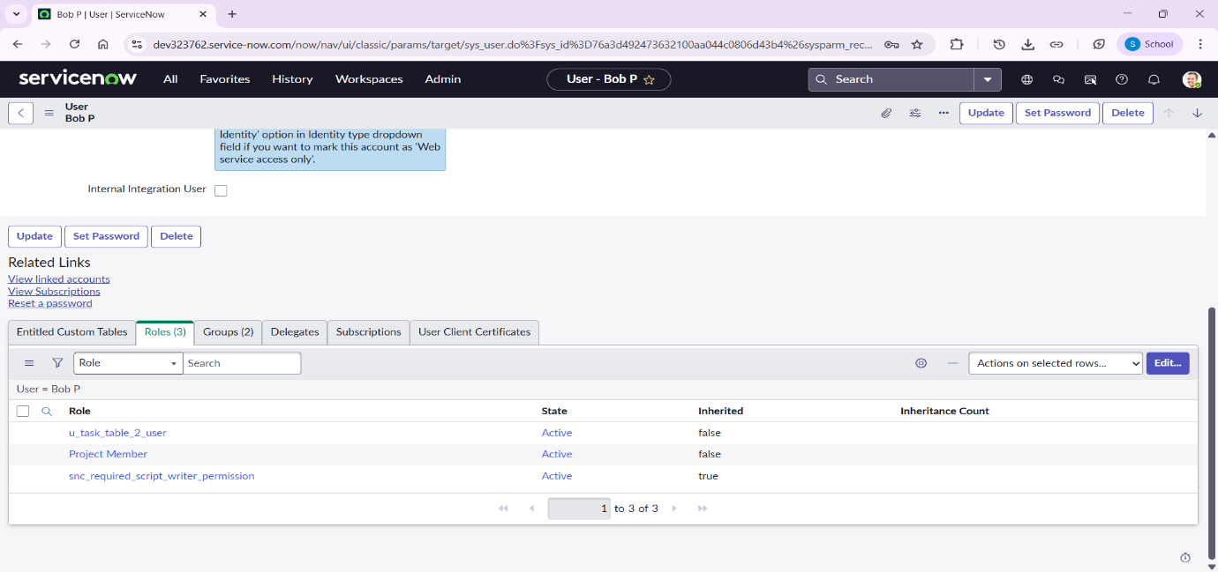
Step 7: Application access
Application Access in ServiceNow refers to settings that control how custom applications and their data (specifically tables) are accessed, read, created, updated, or deleted by other applications within the same instance. These settings manage security between application scopes to prevent unauthorized cross-scope interactions.
- Assign table access to application
- While creating a table it automatically creates a application and module for that table.
- Go to application navigator search for search project table application.
- Click on edit module.
- Give project member roles to that application.
- Search for task table2 and click on edit application.
- Give the project member and team member role for task table 2 application.
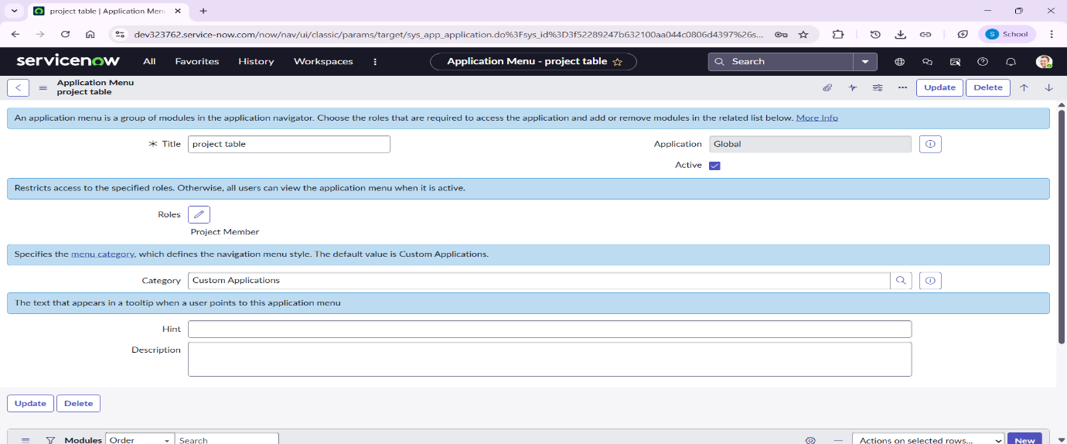
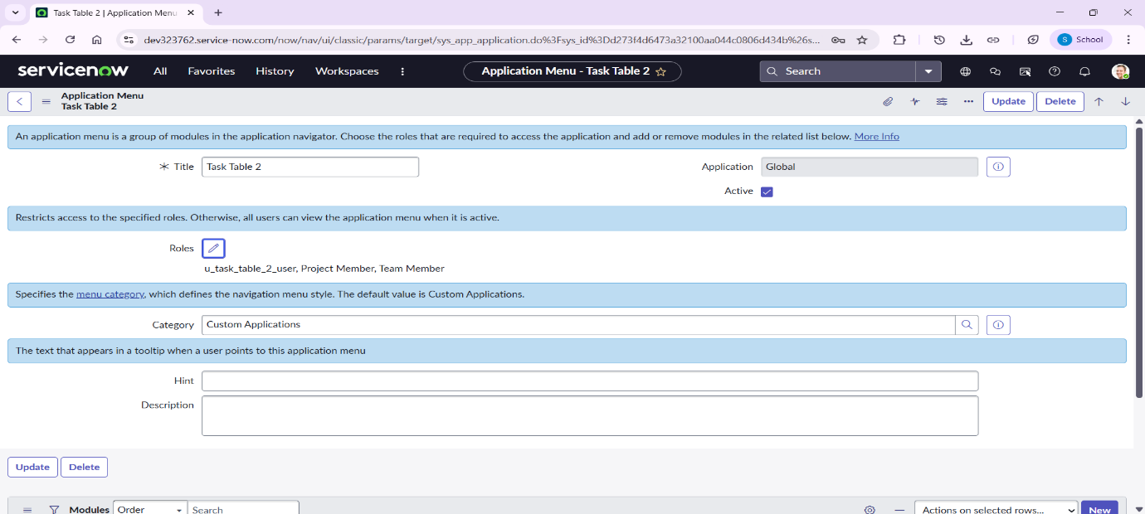
Step 8: Access control list
In ServiceNow, an ACL (Access Control List) is a security rule that governs who can access what data and perform which actions (Create, Read, Write, Delete) on tables, fields, or records, acting as granular security gates for the platform's data, ensuring users only see and modify what they are permitted to, often based on roles, conditions, and scripts.
- Open service now.
- Click on All >> search for ACL.
- Select Access Control (ACL) under system security.
- Click on elevate role.
- Click on new.
- Fill the following details to create a new ACL.
- Scroll down under requires role.
- Double click on insert a new row.
- Give task table and team member role.
- Click on submit.
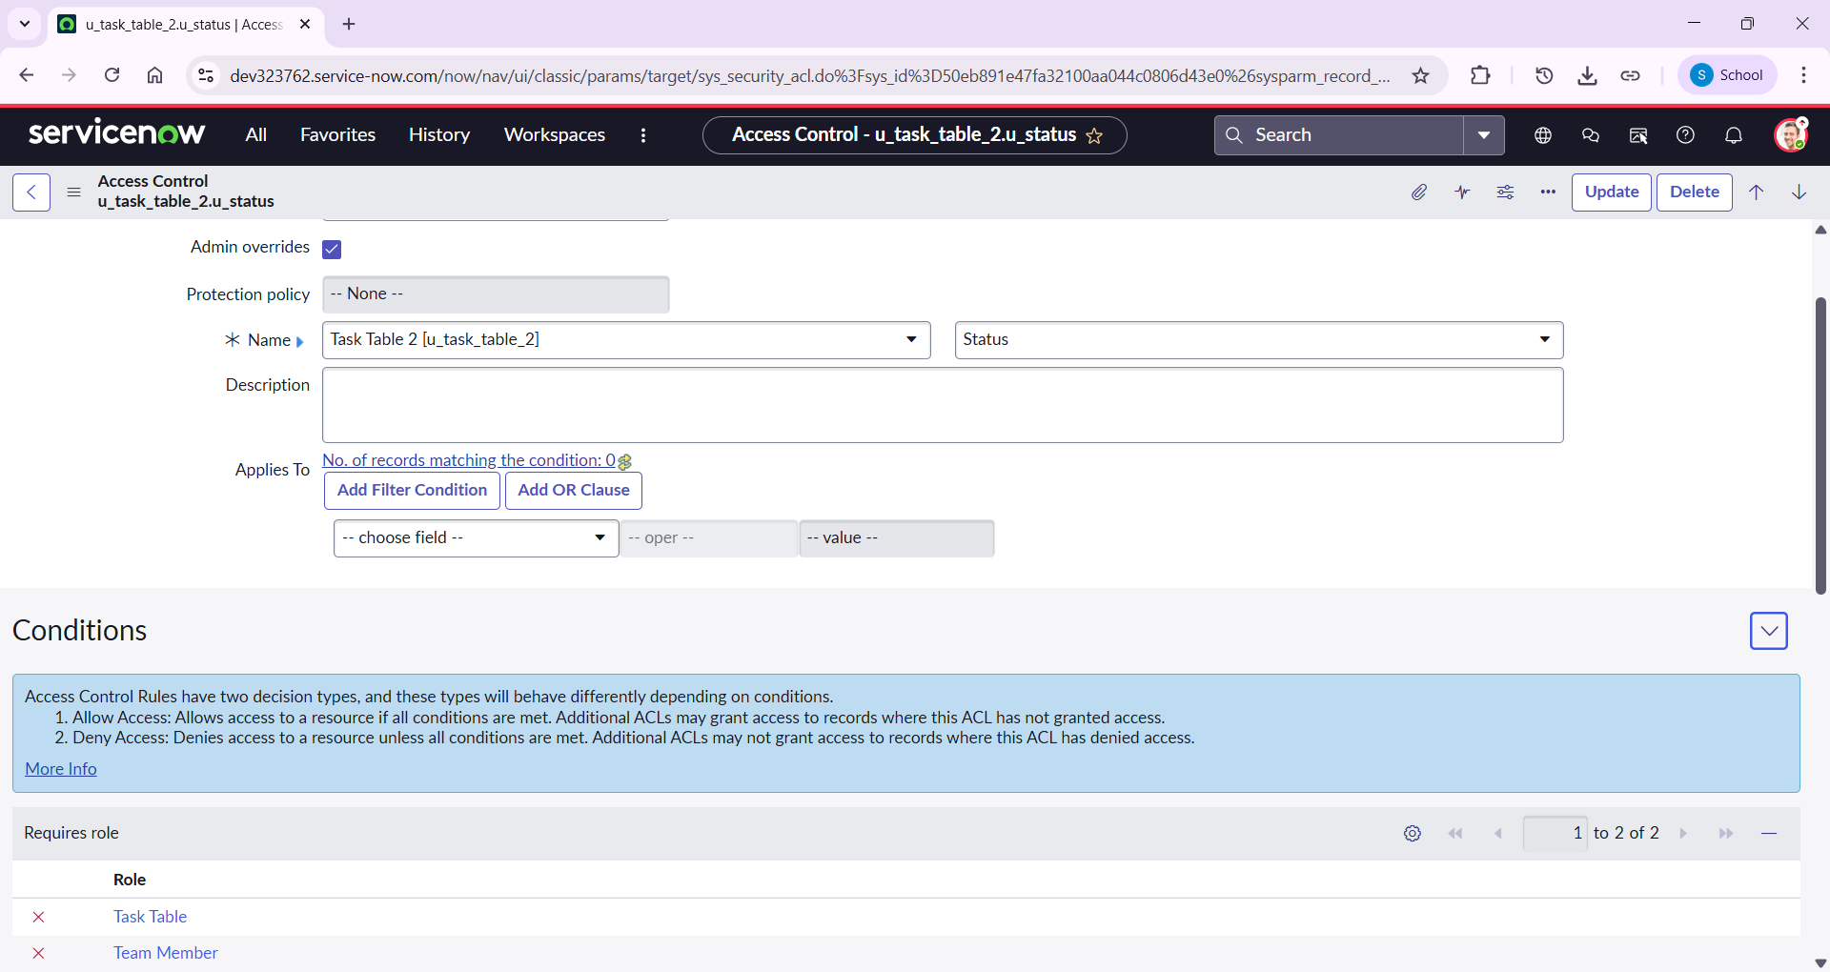
- Similarly create 4 acl for the following fields
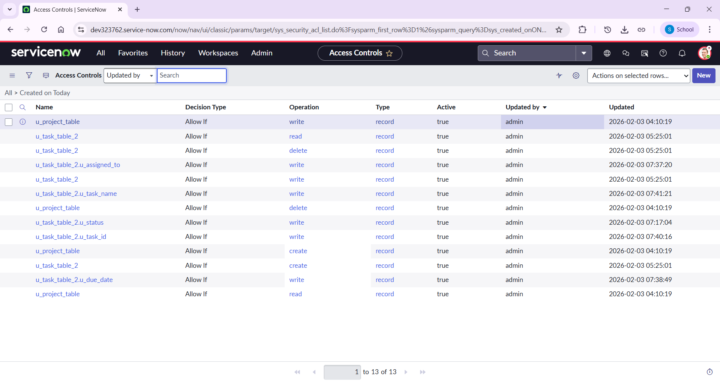
- Click on profile on top right side.
- Click on impersonate user.
- Select bob user.
- Go to all and select task table2 in the application menu bar.
- Comment and status fields are having the edit access.
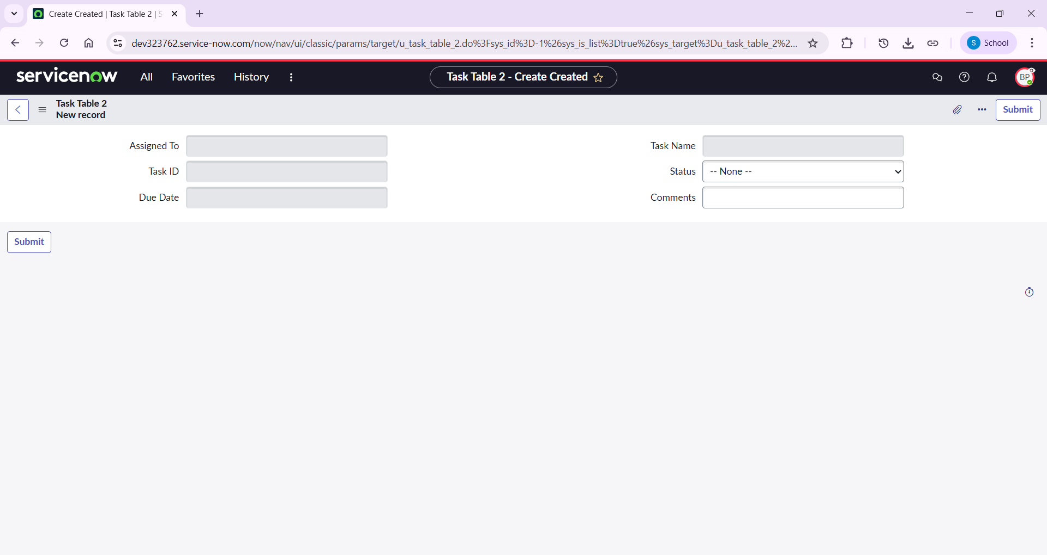

Step 9: Create a Flow to Assign operations ticket to group
- Open service now.
- Click on All >> search for Flow Designer
- Click on Flow Designer under Process Automation.
- After opening Flow Designer Click on new and select Flow.
- Under Flow properties Give Flow Name as “task table”.
- Application should be Global.
- Click build flow.
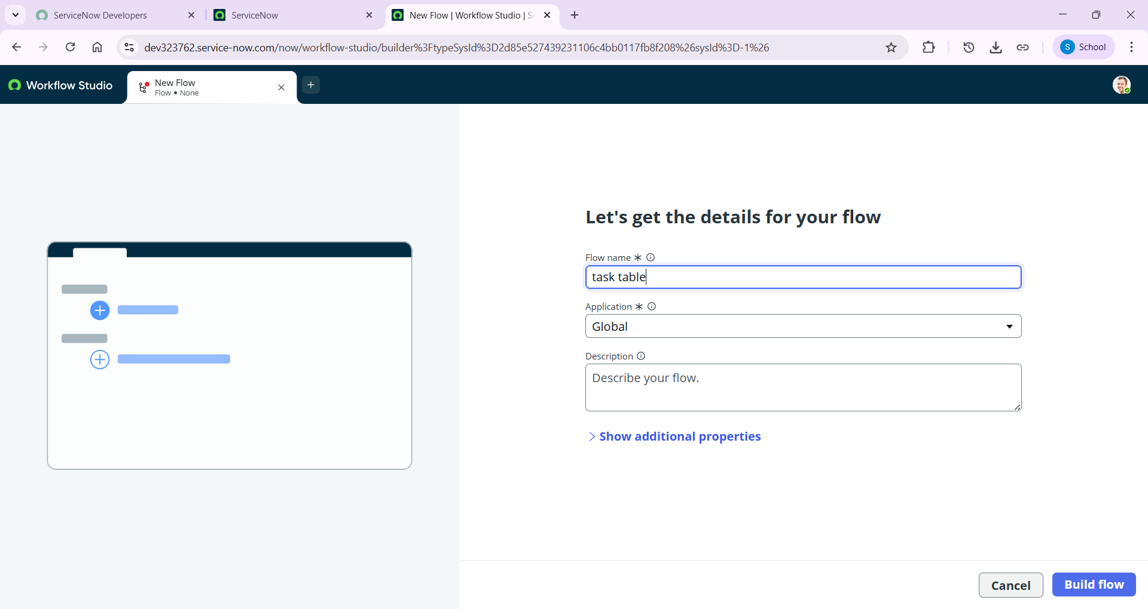
Next step:
- Click on Add a trigger.
- Select the trigger in that Search for “create record” and select that.
- Give the table name as “task table”.
- Give the Condition as:
  - Field: status: is: in progress
  - Field: comments: is: feedback
  - Field: assigned to: is: bob
- After that click on Done.
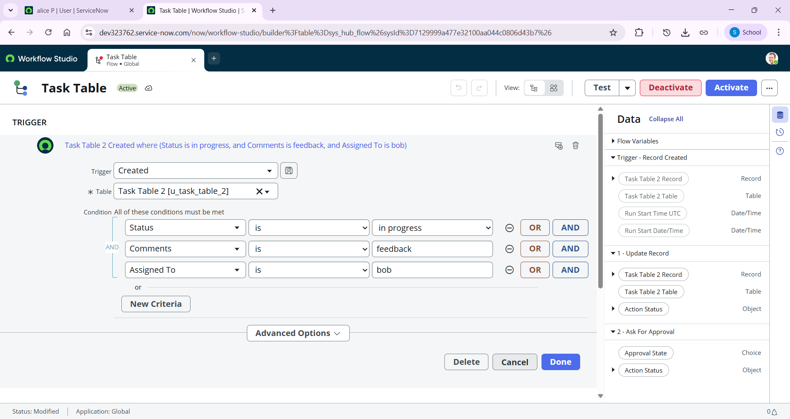
Next step:
- Click on Add an action.
- Select action in that, search for “update records”.
- In Record field drag the fields from the data navigation from Right Side(Data pill)
- Table will be auto assigned after that
- Add fields as “status” and value as “completed”
- Click on Done.
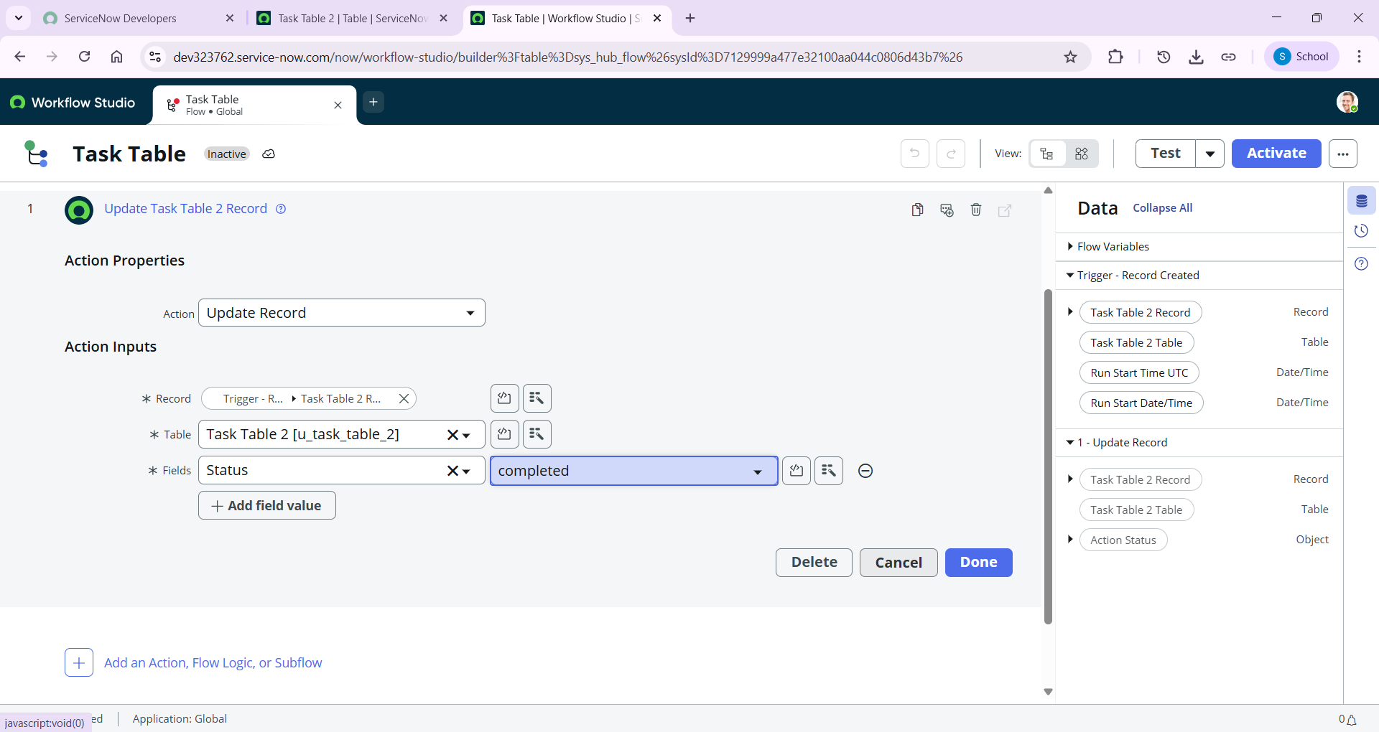
Next step:
- Now under Actions.
- Click on Add an action.
- Select action in that, search for “ask for approval”.
- In Record field drag the fields from the data navigation from Right side
- Table will be auto assigned after that
- Give the approve field as “status”
- Give approver as alice p
- Click on Done.
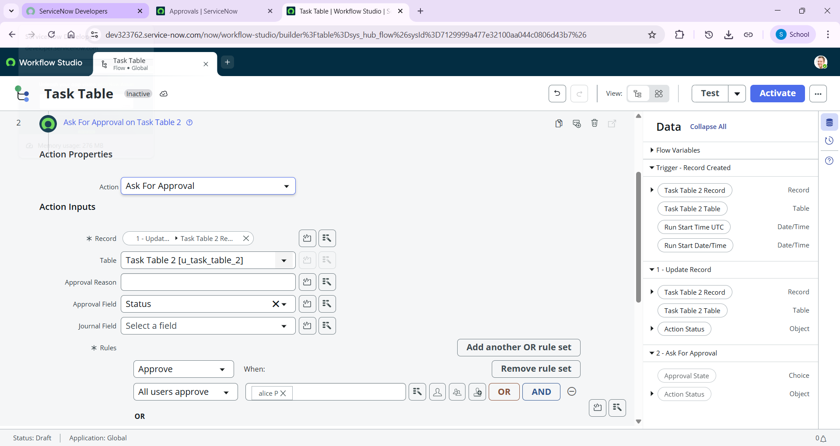
- Go to application navigator search for task table.
- It status field is updated to completed.
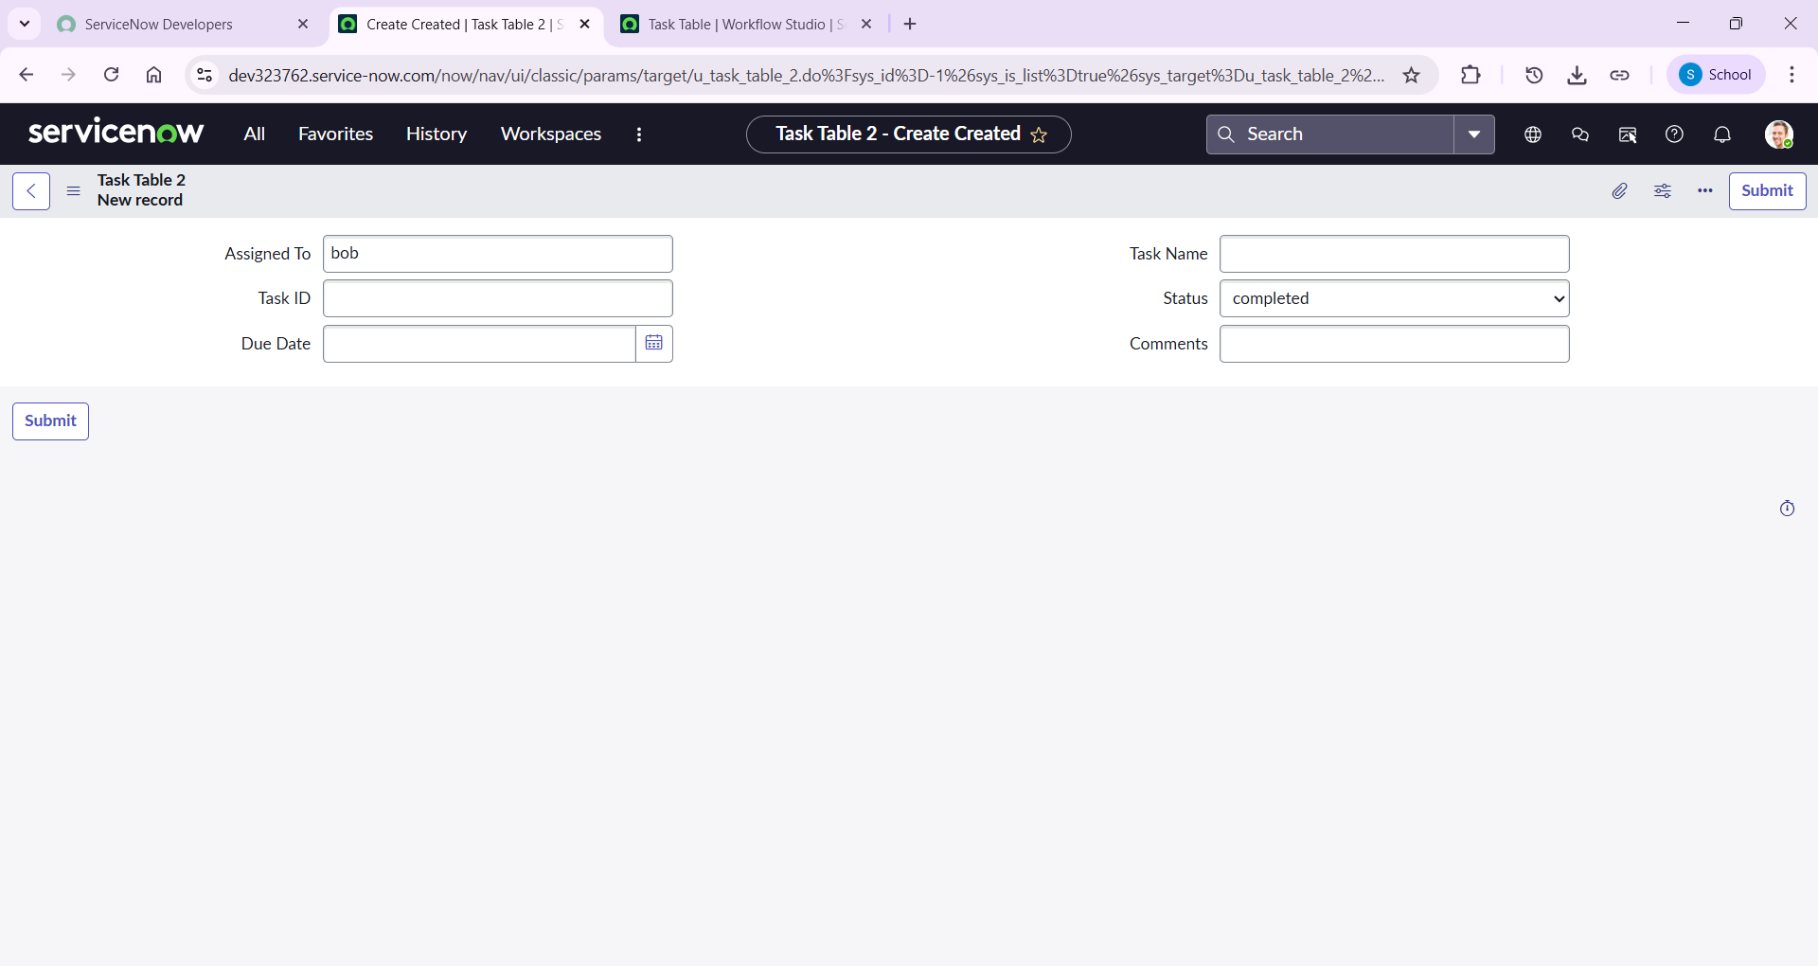
- Go to application navigator and search for my approval.
- Click on my approval under the service desk.
- Alice p got approval request then right click on requested then select approved.
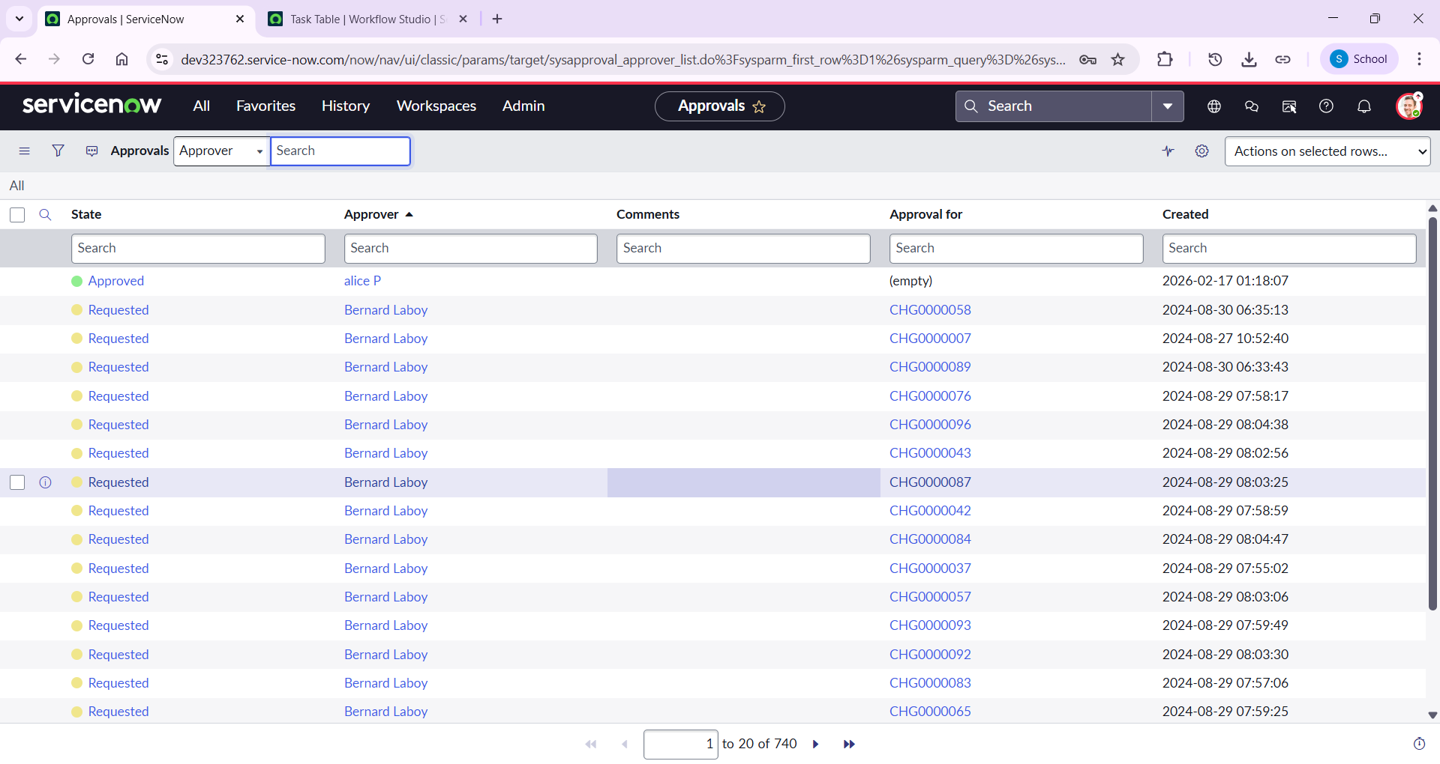

Step 10: Conclusion
This scenario highlights a structured approach to project management, showcasing the roles of Alice and Bob within a defined workflow. With Alice's oversight and Bob's execution, the team effectively collaborates to ensure project success. The use of tables organizes key information, facilitating easy tracking of projects, tasks, and progress updates. Overall, this system promotes accountability, enhances communication, and leads to the successful completion of projects.

